**Integrating LVM with Hadoop and providing Elasticity to DataNode Storage!!!**

Step 1) Start namenode

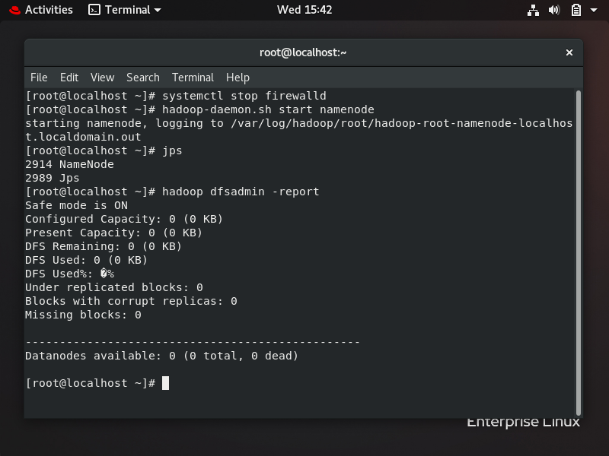

Step 2) Attach hard disk to datanode

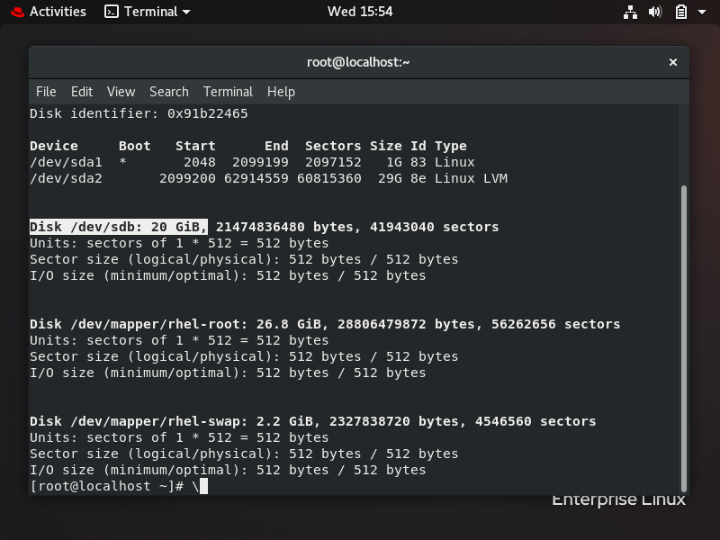

Step 3)Convert hard disk to physical volume(pv) and also create volume group(vg)

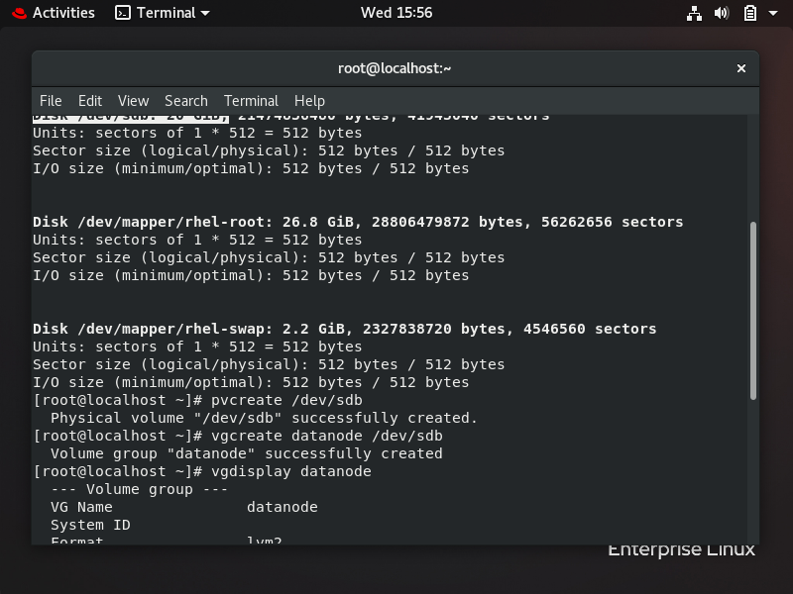

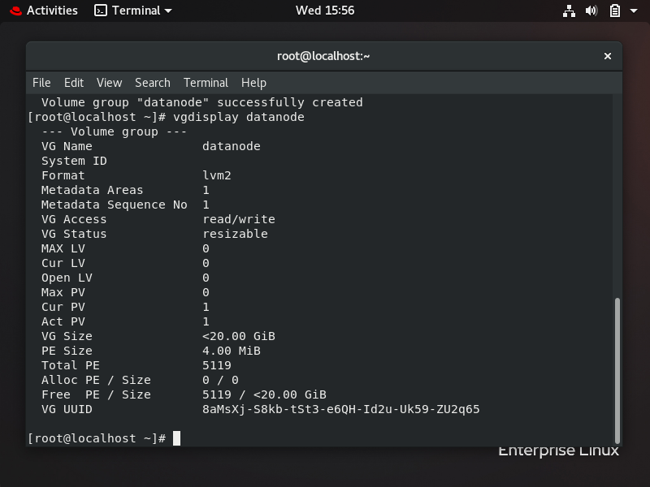

Step 4)Create logical volume(lv)



Step 5)Format that logical volume and mount a folder to it

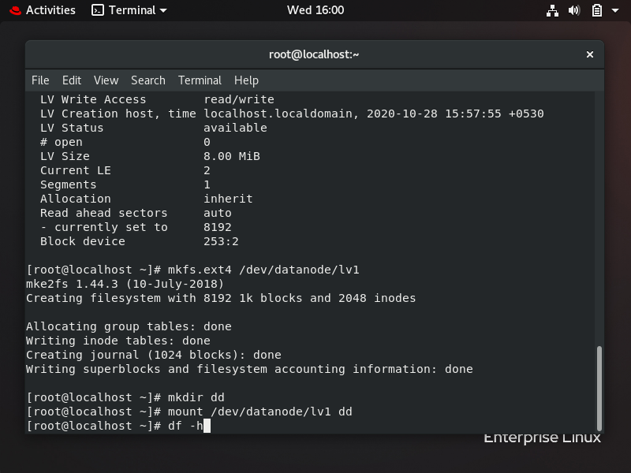

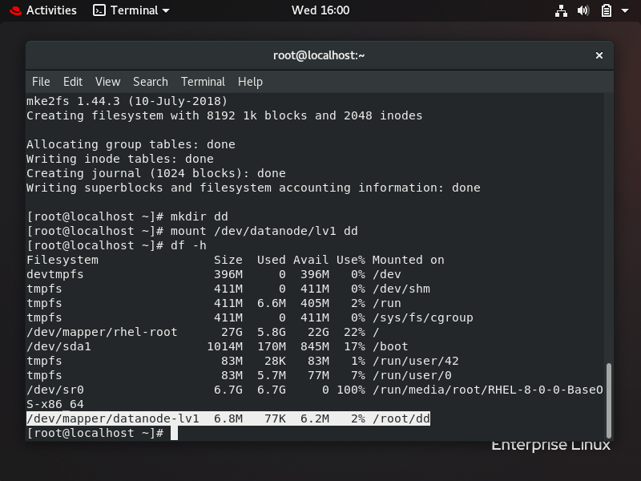

Step 6)Datanode should share that file in HDFS cluster

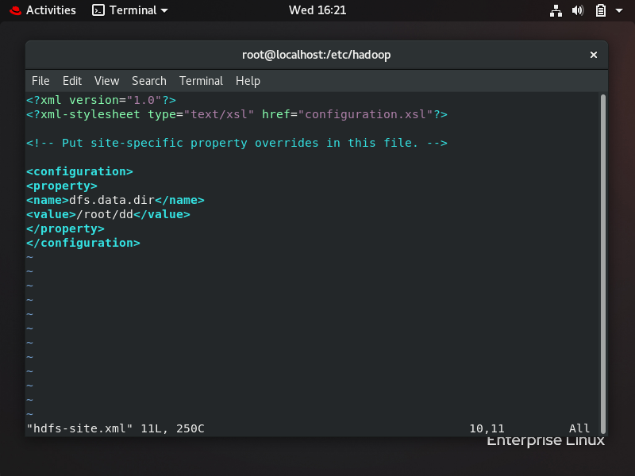

Step 7)Start datanode daemon

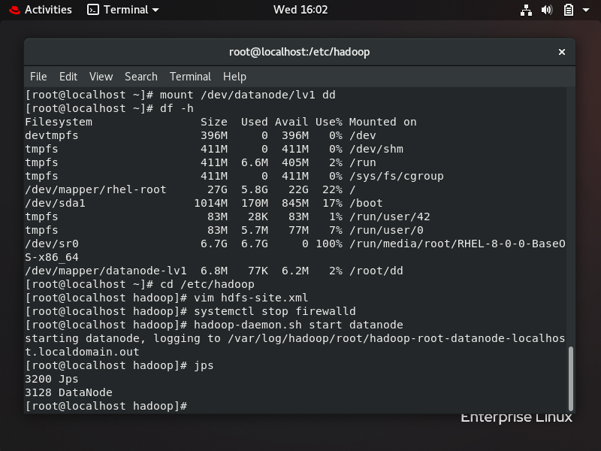

Step 8)Check dfsadmin report

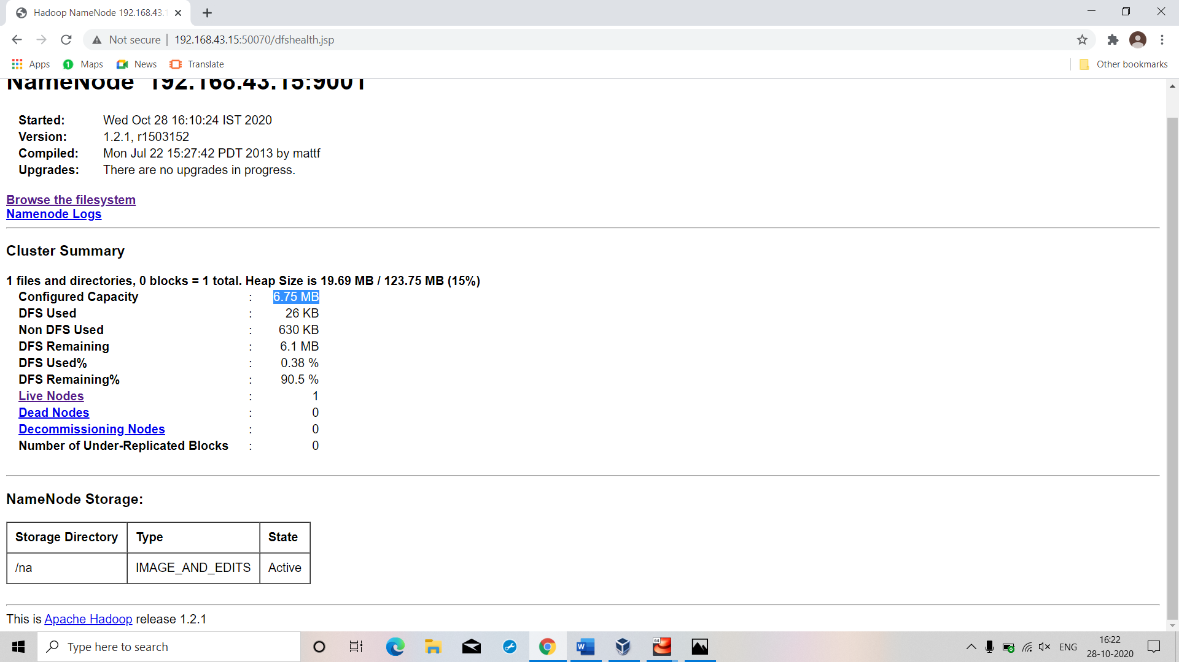

Step 9)Increase/extend size of logical volume while data node is connected to HDFS cluster

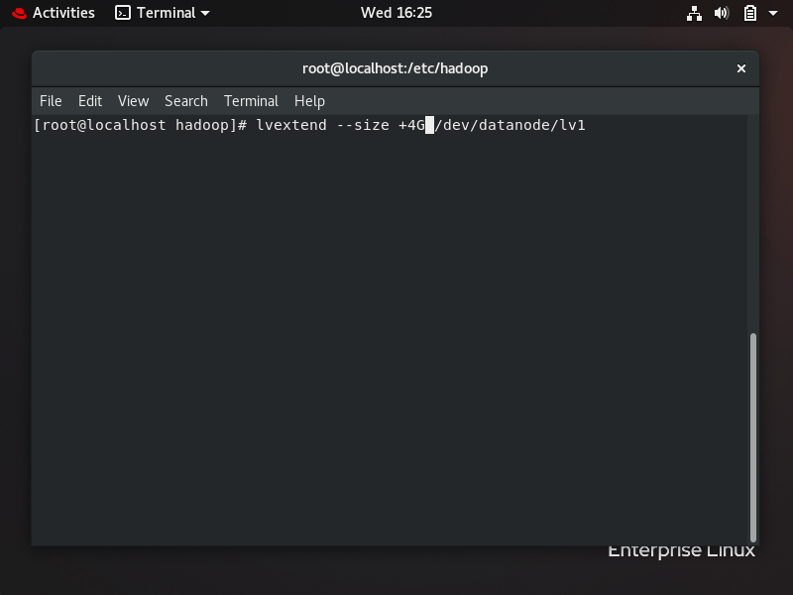

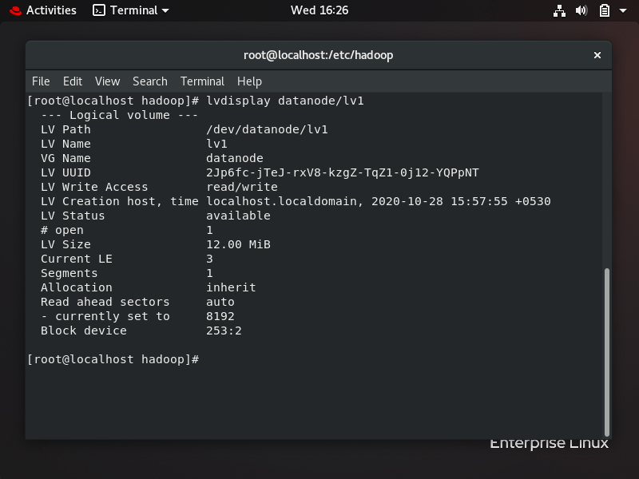

Step 10)we need to format the additional storage added to existing storage ; use “resize2fs” command

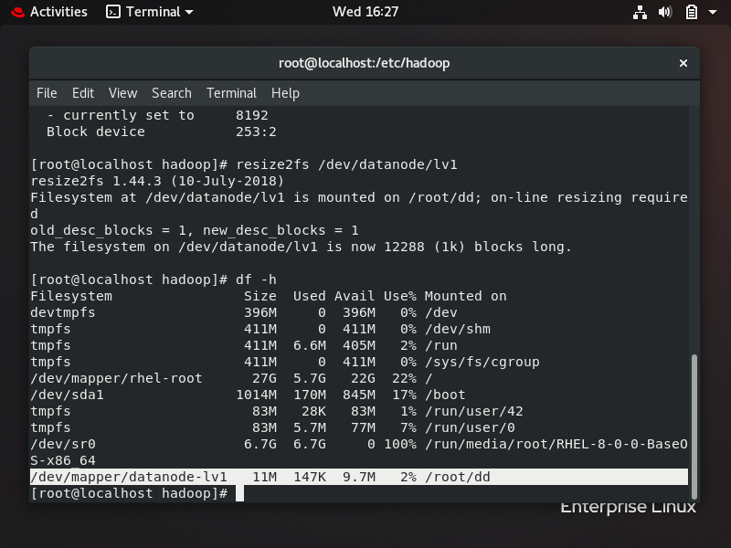

Step 11)Data node while it was connected increased it’s shared storage

